Name Therapist : Name Client :
Date start therapy : Client age :
Therapy goals for Client
Family of origin

Older siblings Younger siblings MF?
Triggers
Bio-

psycho-

social
Symptoms (when client started consulting)

Year of birth
0
Age today
2019

-9mo
Clients own family system

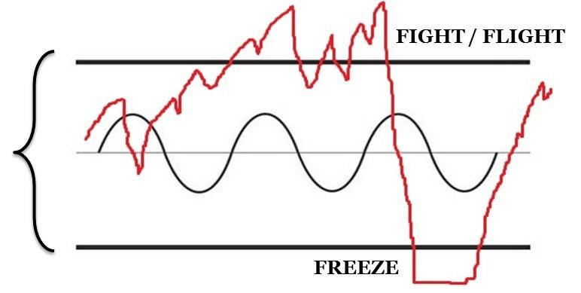
Mark the patient’s predominant
ANS-state in the WOT below
Evaluation:  State of client | Little / type 1  or: good / secure | Medium / type 2  or: not too bad/ insecure | High / type 3  or: bad/ insecure /disorganized
Gravity of symptoms*
Bio-psycho-social**
Affect dysregulation
Fragmentation
Dissociation***
Attachment
Solid core
(and Th’s gut feeling )
Medical history
Treatment plan | Name of protocol | Repetition | Why this protocol
Stage I:
Stage II:
Stage III:

Treatment done | Name of protocol | Repetition | What changed? | Your observation
Stage I:
Stage II:
Stage III:

New informations/ review/updates

